**Trouble-Shooting Guide in IT Support M4**

Software

In occasions there a system can develop an issue with software. This can affect any type of software ranging from OS’s (Operating Systems), to Internet Browsers. In this Leaflet you will find the explanations to help solve these basic problems.

* **Operating Systems**

Issues with an OS can be very serious, causing the machine not to run correctly or completely. Where someone contacts you with an issue regarding the operating system you will need to identify what is wrong so you can solve the issue correctly.

If the **BIOS message** appears, when the computer starts up, you will need check to see if the PC is running from the right drive. The PC needs to run from the hard drive with the OS on it, unless you are installing then it will need to run off the disk drive you are using to install the OS.

If the OS **crashes when it is loaded**, make sure the PC can support the OS and the specification meets the requirements that are needed for the OS. If it is able to run the OS but is still crashing, then try re-installing it. (Be sure to back up important files on the hard drive). If it continues to crash after installation then one of the components may be faulty and will need to be replaced, it could mean replacing the entire machine.

* **3rd Party Software**

Third party software can also cause issues. These includes internet browsers, visual studios or Microsoft office.

Any problems regarding internet browser can be easily sorted out. Either by re-installation and changing a few settings. If you are unable to log in to a website you have previously been able to log in to and you are able to log into the website on another machine then you need to clear the cache to remove the corrupted data which is not allowing you to log on. Issues which prevent homepage changing and loading webpages could be caused by viruses or entering the URL wrong. To solve any virus problems, you need anti-virus software, e.g. MacAfee, Norton or even AVG.

If anything goes wrong with Microsoft office, whether its word, PowerPoint or outlook, it will need to be fixed. There are many possible errors which can occur using this software. It could be that you have an un-registered copy of office, this can be solved by inputting the product key into the registration screen on Microsoft Office. This key are located on the product box (or on the email they sent confirming the download and purchase).

* **Control panel**

The control panels allows the user of the machine to change PC settings; Such as editing the computer theme, desktop background and the user’s password. It is also has the location of the diagnostics tool.

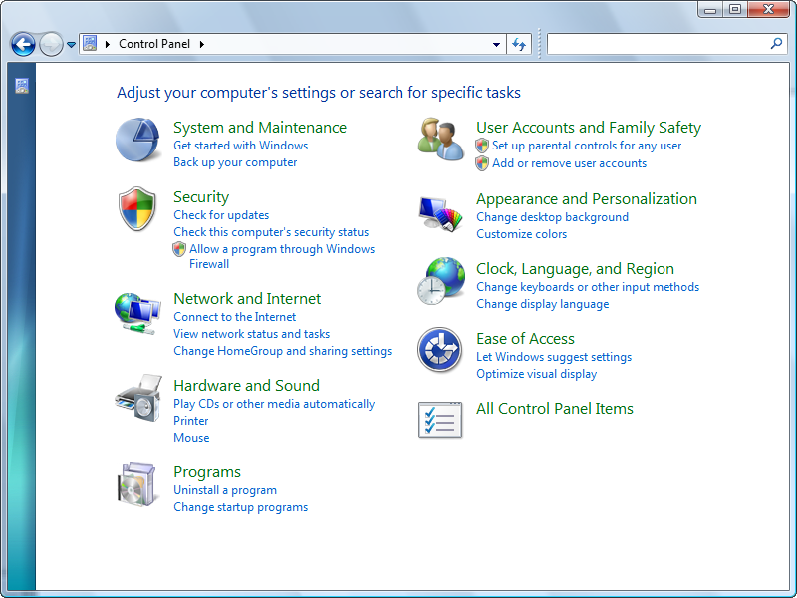

**Hardware**

There will always going to be issues with a computer’s hardware. So here are few problems with their solutions.

* **Windows Performance Index**

Using this helps you understand if a piece of hardware is performing badly compared to the other components in the PC. Each component is rated out of 7.9, with 7.9 being the best, with anything lower getting worse. If you have a component under-preforming, in comparison to other components, it may need to be upgraded to boost PC performance.

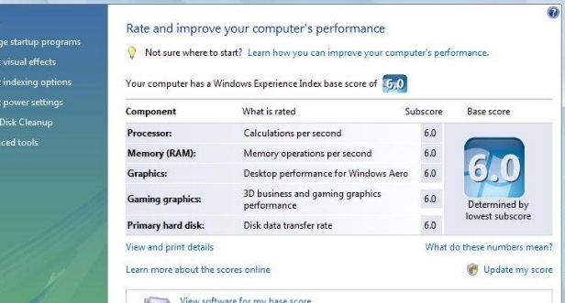

* **Defrag Tool**

This tool helps speed up **OS load time**. This collects all the scattered data, which is spread around in many different place, and places it all together inside the hard drive.

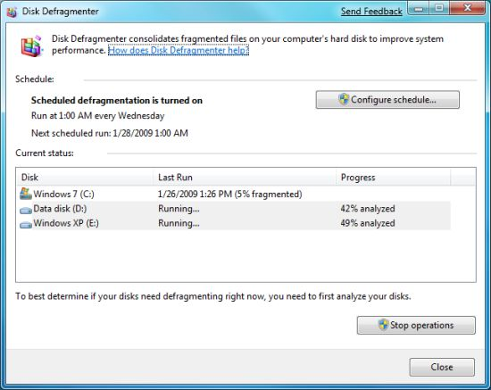

* **Overheating**

If your pc is overheating, there are a few things which could have caused this. Here are some reasons Pc’s overheat and their solutions.

* Dust: This is easily fixed just by blowing the dust away from the components by using pressurised air canisters. Do Not use a cloth or a feather duster as this can cause a build-up of static electricity which is bad for the PC components
* Lack of space: this is solved by moving your computer to a more ventilated location which will improve the cooling of you PC.
* Broken fan: This can easily be replaced cheaply and will make a big difference in the temperature of your PC.
* Constantly on: Leaving your pc on all the time while away can and will cause the Computer to overheat. So just by simply turning it off when you aren’t using it will stop producing the heat which will improve the cooling abilities.